Practical 10 — Secure Login, Logout, Sessions, and Role-Based Access Control

Aim
To sign users in and out securely with sessions, timeouts and role guards so each role reaches only its own areas.

Theory
Authentication proves identity; sessions remember it; authorisation checks the stored role on every protected page before any output, with menus treated as display only.
- Login verifies the password against the stored hash, regenerates the session identifier against fixation, and applies a short inactivity timeout with optional remember-me rotation.
- Separate student and faculty entry points reject mismatched roles with explicit error markers rather than leaking which half failed.
- Every protected page enforces its role on the server before rendering; anonymous visits bounce to login and wrong roles to a denied marker.
- Logout wipes the session and any persistent token on both browser and database sides.
- A central authorisation helper plus login, logout and role migrations implement the flow.

Procedure
- Added the authorisation helper with login, session, timeout, remember-me and role-guard logic.
- Built login and logout endpoints and converted student and faculty dashboards to guarded pages.
- Wired role-matched login forms with invalid-credential and wrong-role markers.
- Added the authentication migration documenting session and token columns.
- Inspected endpoints, guards and login pages on disk; live sign-in was not re-run here without PHP and MySQL.

Screenshots

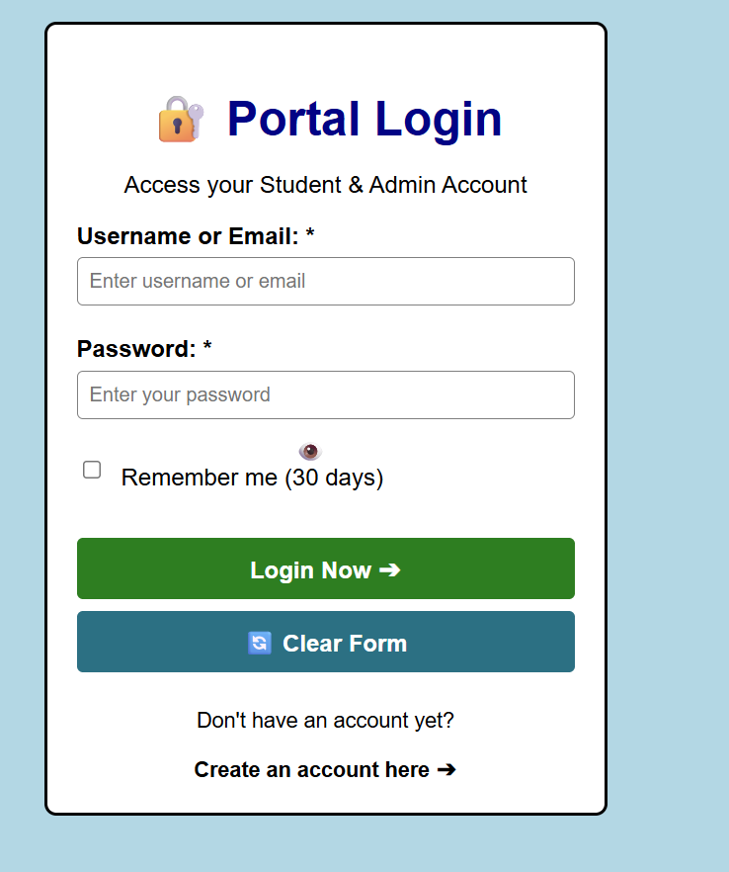

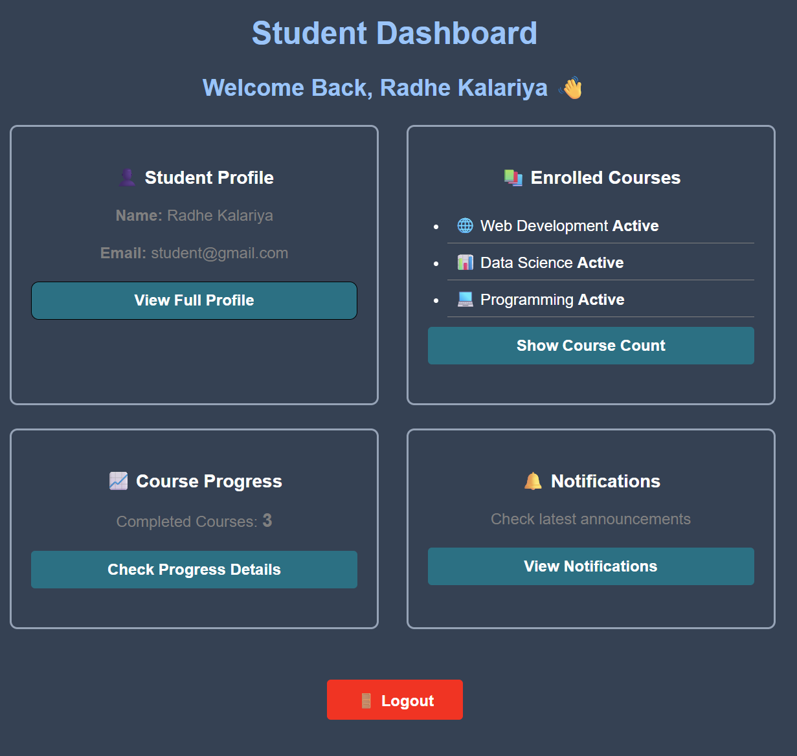

GitHub Repository Link
Practical repository : https://github.com/Rkpatel34/StudentHub/tree/main/studenthub

Conclusion
Practical 10 established trustworthy identity and boundaries: sessions prove who you are, guards decide where you may go.

